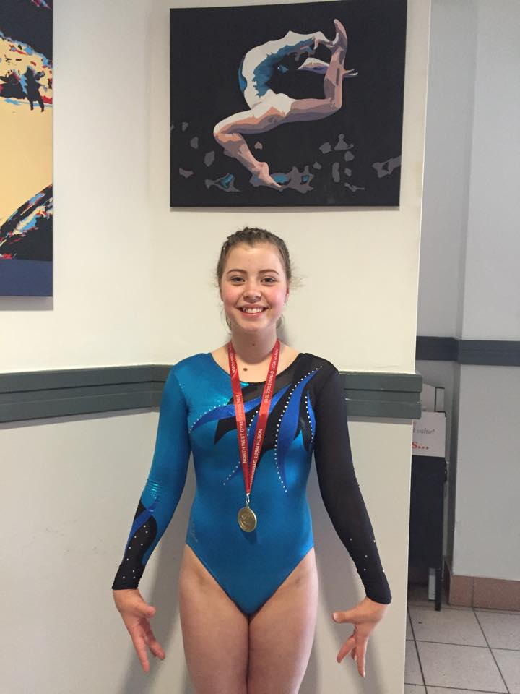
North West Open 2015 - Wigan
On the 7th June, Louise Conlon travelled with Head Coach Vikki Sylvester, to represent Uttoxeter Gymnastics Club and compete in the North West Open in Wigan.
The competition was being used as a warm up for Louise’s trip to London in July to perform in the British Gymnastics Challenge Cup. Gymnasts from all over the North of England, the Midlands and Wales made their way to Wigan to compete.
Louise competed well and, despite a couple of errors, produced some rather complex skills including full and double twists, and flick tuck backs. Such was her performance she was rewarded with the Bronze medal for her floor routine, and came an extremely respectable 4th place overall.
By all accounts it was a great trip for Louise in preparation for the Challenge Cup, gaining valuable experience and besting some great competitors. She travels to London on the 5th July to try her hand against some of Great Britain’s best gymnasts at Espoir Age and all at Uttoxeter wish her the best of luck.

