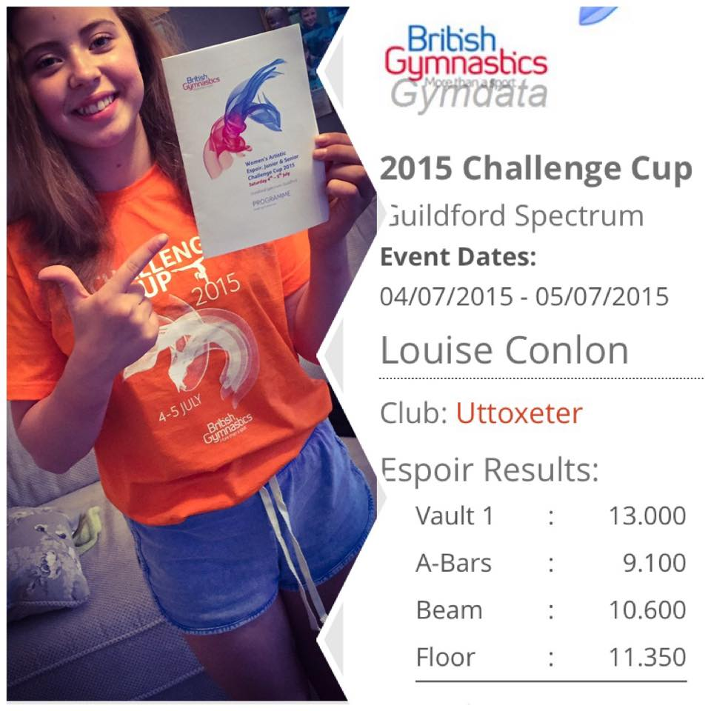
British Gymnastics Challenge Cup 2015 - Guildford
All gymnastic eyes fell on the Spectrum Leisure Centre in Guildford, London as the British Gymnastics Cup was held on the 5th July. Over 70 competitors travelled to the nation’s capital from all corners of the UK to compete for the chance to progress to the British Open Championship later in the year.
One such gymnast was Uttoxeter’s own Louise Conlon, accompanied by Head Coach Vikki Sylvester and Personal Coach Stacey Moreton, to try her very best against the best young gymnasts in the Espoir Age.
Confidence in the camp was high after Louise had narrowly missed out on the podium during the North West Open, and Louise’s camp fully expected a good clean round, and a competitive score. Not only did Louise produce a clean round, she produced some of the best gymnastics of her life. She fully completed each discipline with precision; amazingly her vault gained a score of 13.00 points, enough to place her in the Top 10 for vault.
The 13.00 point vault contributed to an overall score of 44.05, good enough to finish 28th out of the 75 competitors, and only 1.95 points off a place at the British Open Championships, where a score of 46 was needed. Her team was incredibly proud of her efforts and all at Uttoxeter Gymnastics Club would like to wish her hearty congratulations for her exemplary performance, and hopefully it is just the benchmark the club has set for future success. Well done Louise!!!

